

ICS 2240 INTODUCTION TO COMPUTER AND DATA PROCESSING

*GROUP ASSIGNMENT*

PHRECIAH WANGUI HSB212-0006/2022 LEON WACHIRA HSB 212-0379/2022 ANTONY MUHIA HSB 212-0025/2022

1 JOO

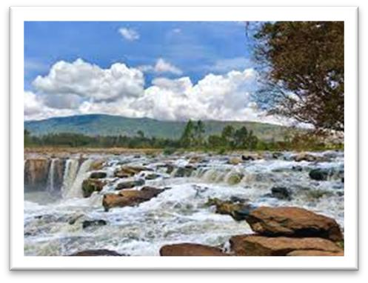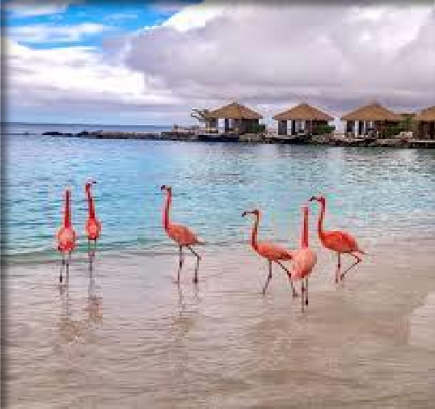

*Figure 1 Book of life*

Figure 2 Fourteen falls

*Figure 3 Flamingo beach Resort*





2

JOO

STUDENTS REVIEW RESULTS

|  |  |  |  |  |  |
| --- | --- | --- | --- | --- | --- |
| NAME | | CAT 1  (OUT OF 40) | CAT 2  (OUT OF 40) | EXAM  (OUT OF 60) | TOTAL |
| Derrick | Wesonga | 24 | 16 | 44 | 64 |
| Amina | Wangari | 27 | 13 | 50 | 70 |
| Kelvin | Mutuku | 32 | 08  60 | | 80 |
| Lavin | Cherono | 18  22 | | 55 | 75 |